CO2 AT1
Name: Raghul. D
Reg.no: 192425328
Question 1:
Q23.Linear Search – Single Match in Middle Position
Given the unsorted dataset [14, 28, 35, 47, 59, 63, 71], apply Linear Search to find the element 47. Clearly interpret the problem and explain the sequential search process step-by-step. Count the number of comparisons needed before the target is found. Analyze the best-case, average-case, and worst-case time complexity. Verify the correctness of the result. Interpret the efficiency of Linear Search when the target lies near the middle of the list.
Question 2:
Q36.Closest Pair – Weather Station Proximity Analysis
A region contains weather stations at coordinates {(1,1), (3,4), (6,6), (2,2), (8,1), (5,5)}. Apply the Closest Pair Brute Force algorithm to identify the nearest pair of stations. Clearly interpret the problem and justify the use of the brute force approach. Compute distances between all possible pairs and show the calculations clearly. Identify the closest pair and count the total number of comparisons performed. Analyze the time complexity of the method. Verify the correctness of the result and interpret its significance in station network planning.

Answer:
1)
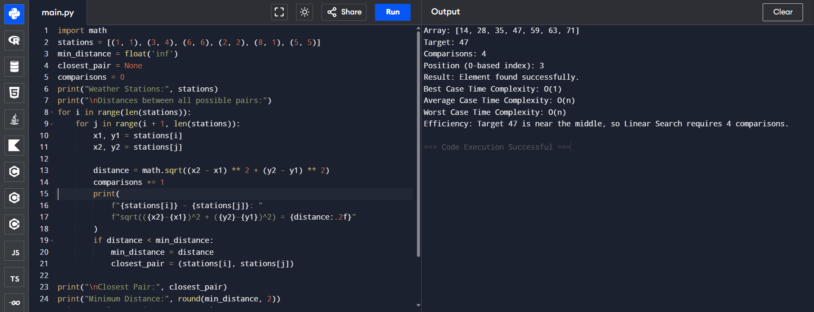

2)


